Setting up Application
Environment Install IBM
Cloud CLI

Step 1. Navigate to cloud.ibm.com
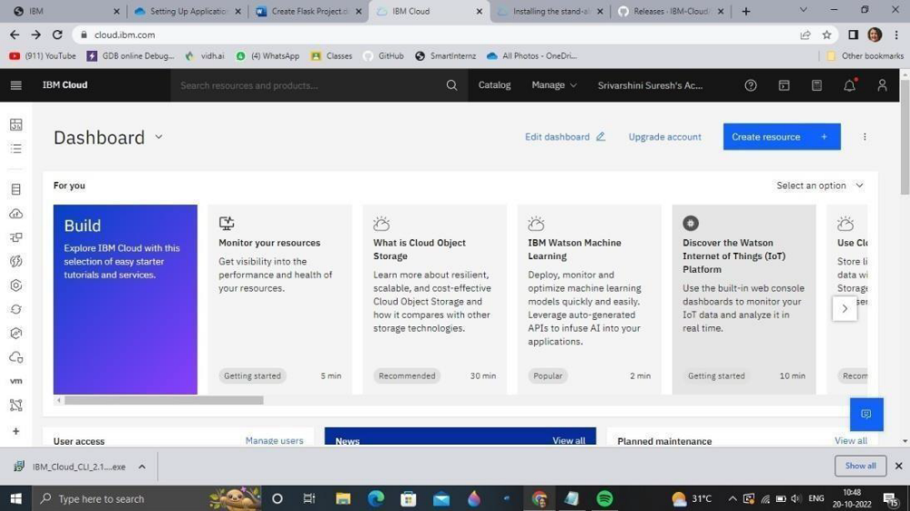
Step 2. Search on Container Registry and give get started and follow the steps to install IBM Cloud CLI

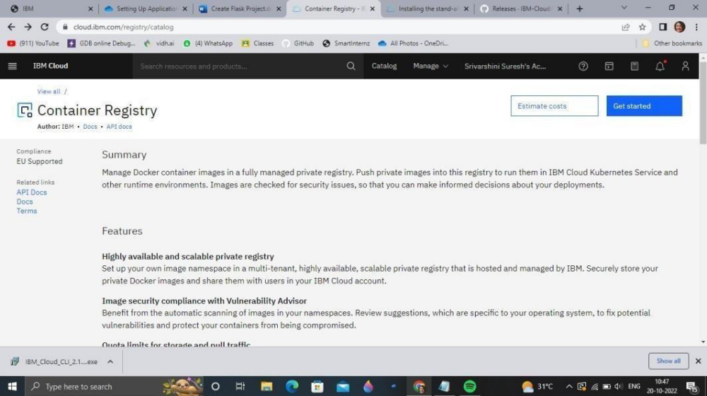

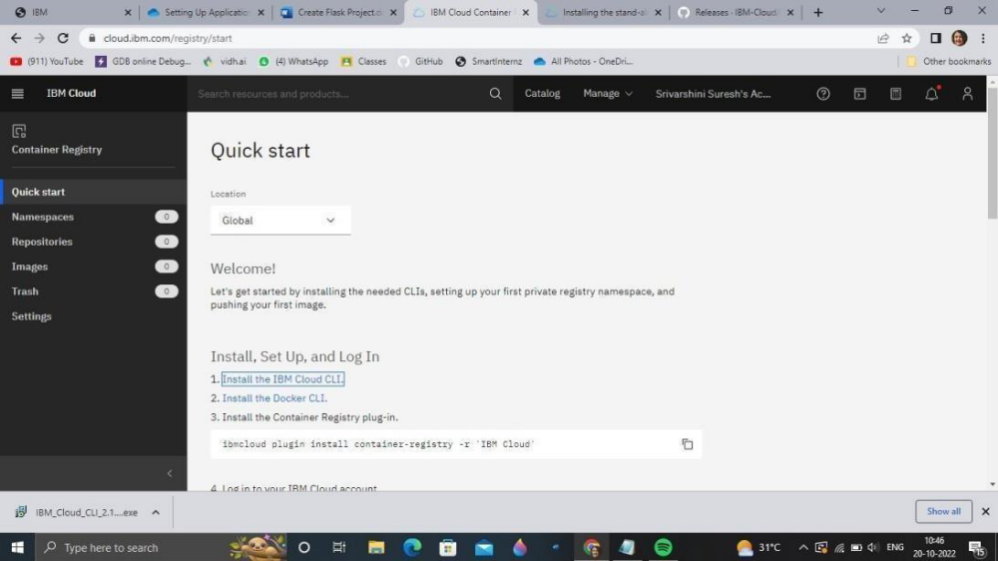

Step 3.Download windows 64 bit installer

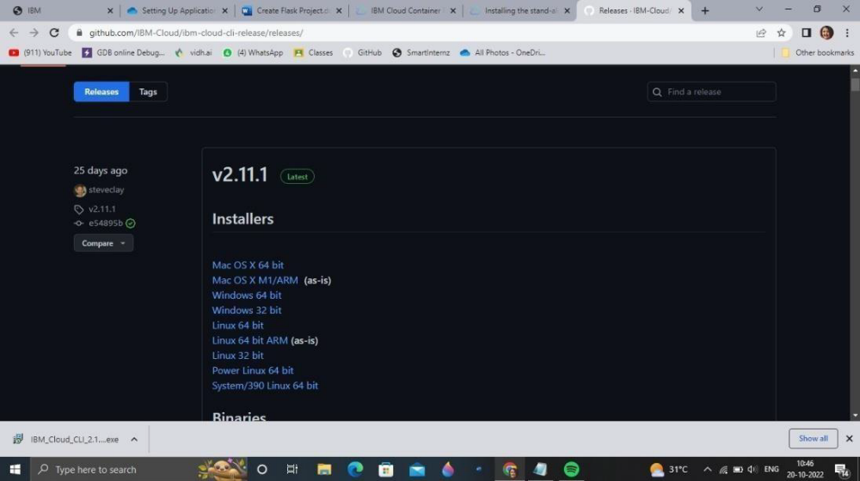

Step 4. Open the downloaded .exe file and run it to install IBM Cloud CLI
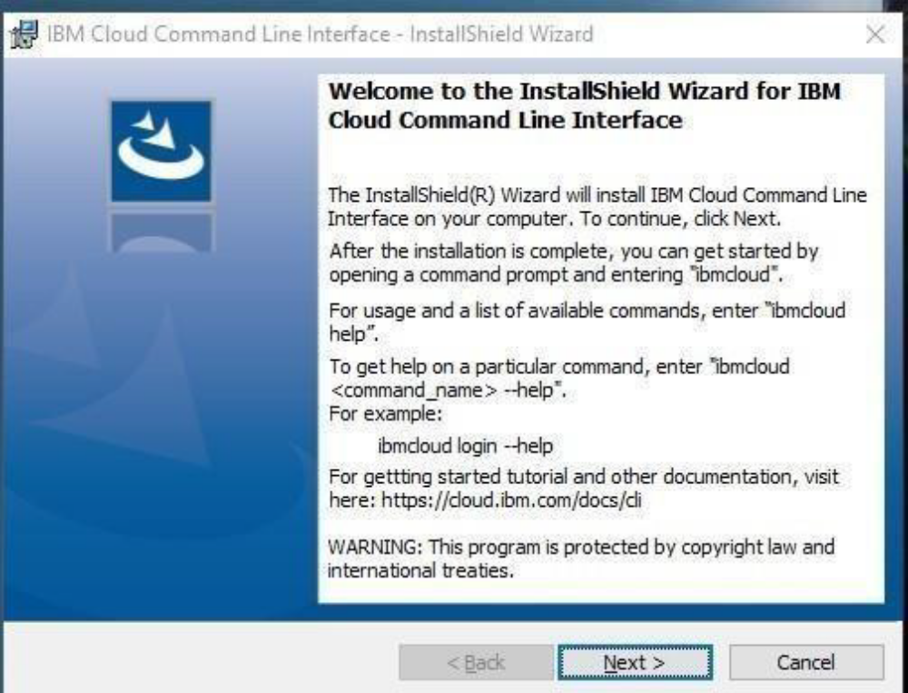

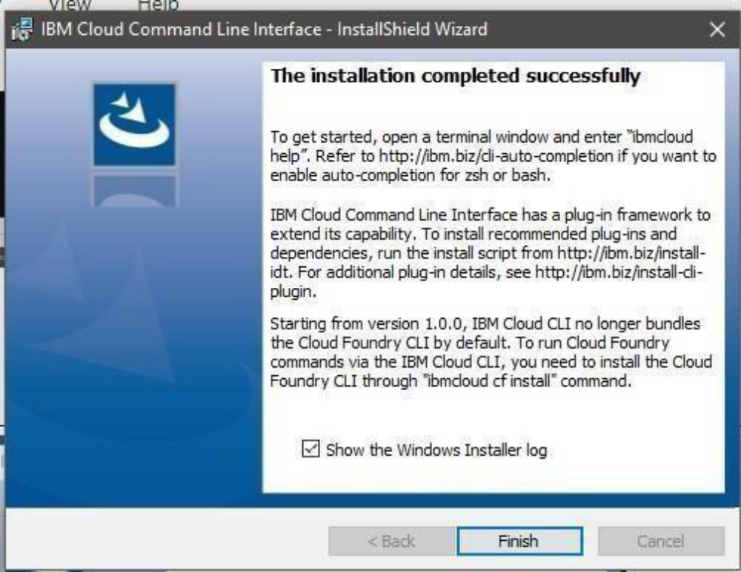

OUTPUT:
IBM Cloud CLI is installed successfully

